Project Design Phase–II
Data Flow Diagram & User Stories
Date | 15 February 2026
Team ID | LTVIP2026TMIDS72262
Project Name | Importing & Securing Data in ServiceNow
Maximum Marks | 4 Marks

Data Flow Diagrams
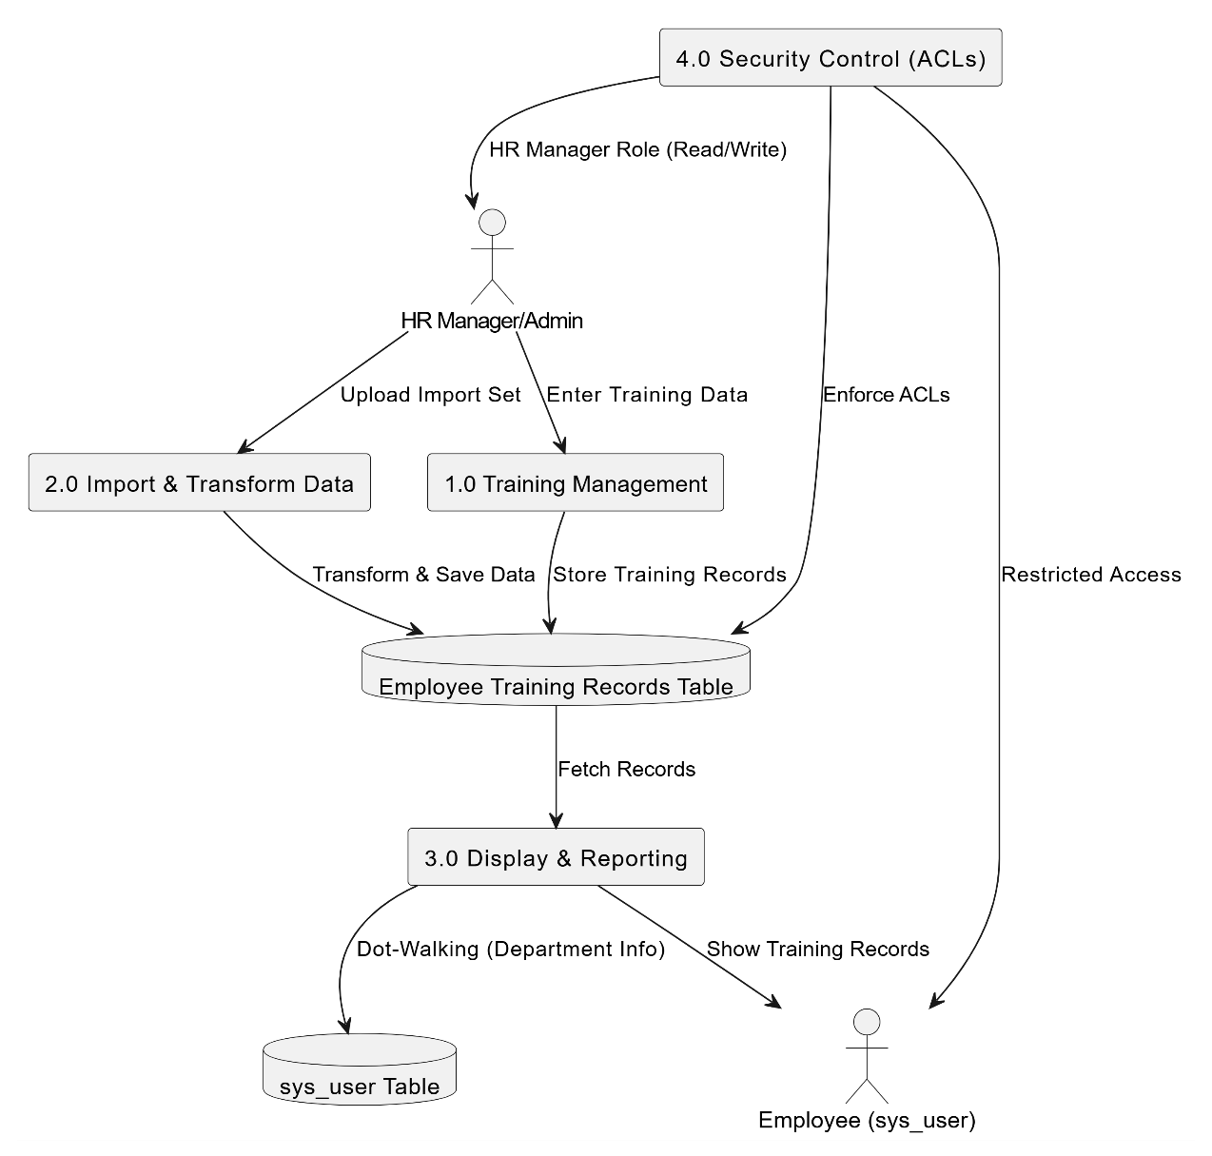

A Data Flow Diagram (DFD) represents how employee training information moves within the ServiceNow system. It visually explains how training data is imported, processed, stored, and accessed securely by authorized users.
The diagram illustrates:
- Data entry through Import Sets
- Data transformation using Transform Maps
- Storage in Employee Training table
- Retrieval of employee details through reference fields
- Secure access enforced using roles and ACLs
Data Flow Diagram (DFD) – Importing & Securing Data in ServiceNow
External Entity
- HR Manager / Administrator
Processes
- Training Data Upload
- Data Transformation
- Employee Linking
- Access Control Validation
- Training Record Management
Data Stores
- Employee Training Table
- sys_user Table
- Role & ACL Configuration
Output
- Secure Employee Training Records with Department Information

User Stories
User Type | Functional Requirement (Epic) | User Story Number | User Story / Task | Acceptance Criteria | Priority | Release
Developer | Project Setup | USN-1 | Set up ServiceNow developer instance and environment. | Instance is active and accessible with admin privileges. | High | Sprint-1
Developer | Application Setup | USN-2 | Create scoped application in ServiceNow Studio. | Application scope created successfully. | High | Sprint-1
Developer | Table Design | USN-3 | Create Employee Training table. | Table created with required structure. | High | Sprint-1
Developer | Field Configuration | USN-4 | Add Training Name, Completion Date, and Status fields. | Fields visible in table form. | High | Sprint-1
Developer | Reference Configuration | USN-5 | Configure Employee reference field to sys_user table. | Employee records linked successfully. | High | Sprint-1
Administrator | Data Import | USN-6 | Upload training data using Import Sets. | Data uploaded without errors. | High | Sprint-2
Administrator | Data Transformation | USN-7 | Create Transform Map for data mapping. | Fields mapped correctly. | High | Sprint-2
Developer | Data Processing | USN-8 | Execute transform process. | Records inserted into Employee Training table. | High | Sprint-2
Administrator | Data Validation | USN-9 | Verify imported employee training records. | Data accuracy confirmed. | High | Sprint-2
Developer | Dot-Walking | USN-10 | Display employee department using dot-walking. | Department visible in list view. | High | Sprint-2
Administrator | Role Management | USN-11 | Create HR Manager role. | Role available for assignment. | Medium | Sprint-3
Administrator | Security Setup | USN-12 | Create Read ACL for Employee Training table. | Authorized users can view records. | High | Sprint-3
Administrator | Security Setup | USN-13 | Create Write ACL for Employee Training table. | Authorized users can edit records. | High | Sprint-3
HR Manager | Access Control | USN-14 | Assign HR Manager role to users. | Users gain correct permissions. | Medium | Sprint-3
HR Manager | Testing | USN-15 | Perform impersonation testing. | Unauthorized users cannot access table. | Medium | Sprint-3
HR Manager | Record Management | USN-16 | View employee training records. | Training data displayed correctly. | Low | Sprint-3
HR Manager | Record Update | USN-17 | Update training completion status. | Changes saved successfully. | Low | Sprint-3
Organization | Reporting | USN-18 | Generate department-wise training reports. | Reports display accurate training data. | Medium | Sprint-3

